**Kocaeli University Electronics and Telecommunication Engineering**

**Digital Communications Laboratory**

**Experiment 2: Pulse Code Modulation (PCM)- Simulink Lab Report(04.03.2024)**

|  |
| --- |
| Name-Surname-Number: |
| Name-Surname-Number: |
| Name-Surname-Number: |

In digital communication system, input of the modulator must be digital signal. If the signal source generates an analog signal, it should be converted digital form via analog-to-digital converter (ADC). ADC includes three steps:

1. Sampling
2. Quantization
3. Pulse Code Modulation (PCM).

$x_{s}$ and $x_{c}$ denote sampled signal output and quantization level, respectively. The quantization error (e) is calculated as follows:

$${e= x}_{s}-x_{c}$$

All required blocks and parameters for the PCM Block experiment are given in Figures 1 and Table 1. Based on these, build the below diagram in Simulink and answer the following questions in detail.

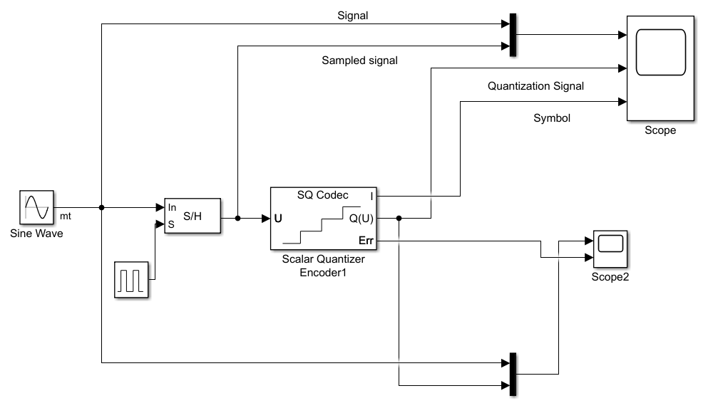

**Figure 1**. A basic PCM block

**The required blocks are given below:**

1. Sine Wave Generator

2. Sample and Hold

3. Scaler Quantization Encoder

4. Scope and Mux blocks

**Parameters of Sine Wave and Quantization Blocks**

|  |  |
| --- | --- |
|  |  |
| **Figure 2**. Block Parameters | |

**Q1)**Set signal frequency as 1 Hz and phase pi/2, sampling frequency as 10 Hz. Run the code for 1 seconds and fill the table. What is the maximum quantization error?

|  |  |  |  |  |  |  |  |  |  |  |
| --- | --- | --- | --- | --- | --- | --- | --- | --- | --- | --- |
| Time (S) | 0 | 0.1 | 0.2 | 0.3 | 0.4 | 0.5 | 0.6 | 0.7 | 0.8 | 0.9 |
| Output of the sampled signal | **0** | **8.090e-01** | **3.090e-01** | **3.090e-01** | **-8.090e-01** | **-1.000e+00** | **-1.000e+00** | **-8.090e-01** | **3.090e-01** | **8.090e-01** |
| Output of the quantization | **-2.500e-01** | **7500e-01** | **2500e-01** | **2500e-01** | **-7500e-01** | **-7500e-01** | **-7500e-01** | **-7500e-01** | **2500e-01** | **7500e-01** |
| Quantization error (look at “Scope 2”) | **2500e-01** | **5902e-02** | **5902e-02** | **5902e-02** | **-5902e-02** | **-2500e-01** | **-2500e-01** | **-5902e-02** | **5902e-02** | **5902e-02** |
| PCM value (“Symbol” signal that is connected to “Scope”) | **1.000e+00** | **3000e+00** | **2000e+00** | **2000e+00** | **0e+00** | **0e+00** | **0e+00** | **0e+00** | **2000e+00** | **3000e+00** |

**Q2)**How many bits are used in **Q1**?

**4bit-Efe,**

**Q3)**If 3 bits are used in quantization, write quantization levels and PCM code for each quantization level (in binary numbers) in the table below (*use zero level for output*).

|  |  |  |  |  |  |  |  |  |
| --- | --- | --- | --- | --- | --- | --- | --- | --- |
|  | 1 | 2 | 3 | 4 | 5 | 6 | 7 | 8 |
| Quantization levels | **0** | **1** | **2** | **3** | **4** | **5** | **6** | **7** |
| PCM Code (binary) | **000** | **001** | **010** | **011** | **100** | **101** | **110** | **111** |

**Q4)**What is the interval of the quantization level for 3 bits case (quantization step)?

**L=2^n (n=bit sayısı), ⅅ=2*Xm/L=2*1/8=0.25**

**Q5)**Calculate the quantization error power for 2 bits and 3 bits. Make comment.

**(ⅅ^2)/12**

**3bit için= 0.0052**

**2bit için= 0.0208**